**Running PyBFS: Step-by-Step Guide**

Here are the steps to run the PyBFS model for baseflow simulation and forecasting:

1. **Import libraries**

1. **Upload input files**

Streamflow data and calibrated parameters file serve as input data to run the PyBFS model. The streamflow data should be converted to m3/d because the BFS flow parameters are in m3/d.

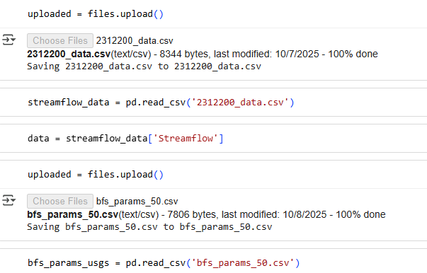

1. **Run the model functions**

These are functions that are needed by the PyBFS model in its hydrological simulations; sur_z (saturated thickness), sur_store (surface storage), sur_q (Qs), dir_q (Qd), infiltration (I), recharge (R). ‘get_values_for_site’ function extract calibrated parameters for a particular usgs site from the uploaded bf_params csv file.

1. **Run PyBT**

This creates a base table that contains the values of the saturated thickness, storage, and discharge in the base reservoir along the length (Xb) of the basin.

1. **Run PyBFS**

This simulates streamflow, baseflow, surface flow, direct runoff, infiltration, recharge, base storage, surface storage, saturated thickness in the base and surface reservoir.

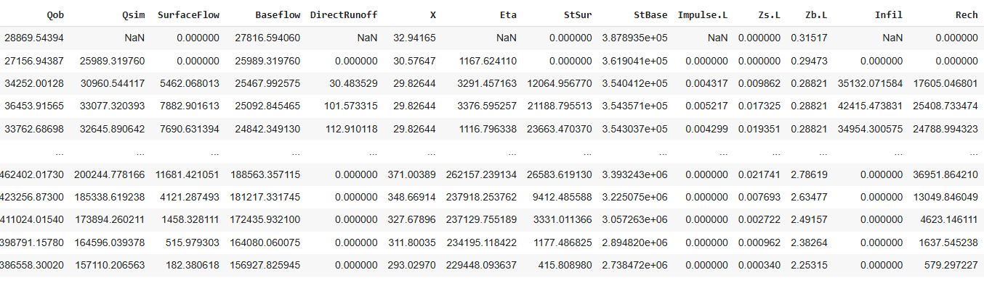

1. **Visualize Data**

Flow data results are in m3/d. This can be converted to m3/s by dividing by 86400.

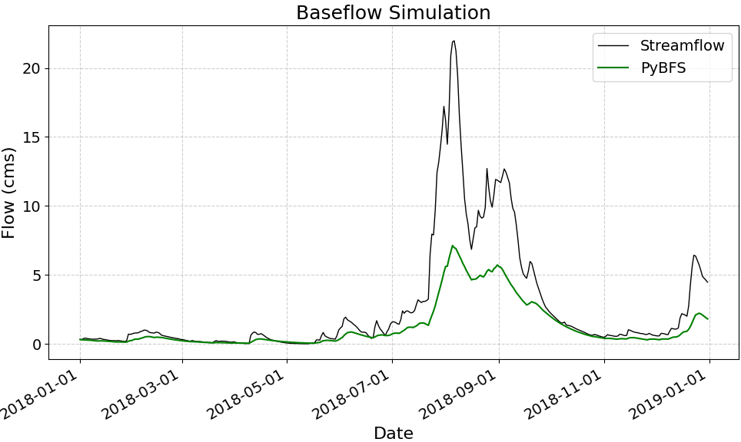

1. **Perform forecasting (PyBFS)**
2. Identify drought periods on the hydrograph

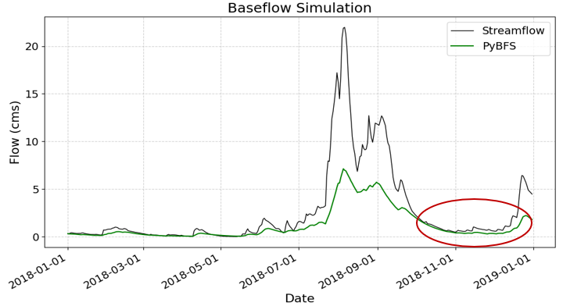

1. Run PyBFS from January (2018-01-01) to September (2018-09-30)
2. Extract the 8 initial condition values for the forecast. This is obtained from the last timestep simulated (2018-09-30).



1. Short-term Drought Forecast for October to December

